Dark Dream – Characters

Wernher Kuntz
Age: 30

Adeline Bézier
Age: 24

Dr. Bernstein
Age: 62

Nazi doctor
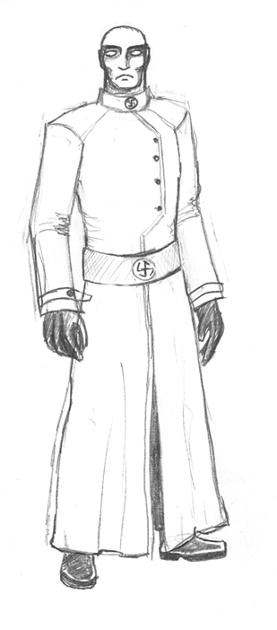

Nazi dreamers

Devil


Zombie lunatic
